Figure 1: The underlying model for the scorecard has an AUC of 0.82, and Accuracy of 76%. A cutoff score of >519 was chosen to maximize profit. Using this scorecard and cutoff for granting credit is expected to generate a profit of $833 per customer and an acceptance rate of ~75% with a default rate of 1.64%.

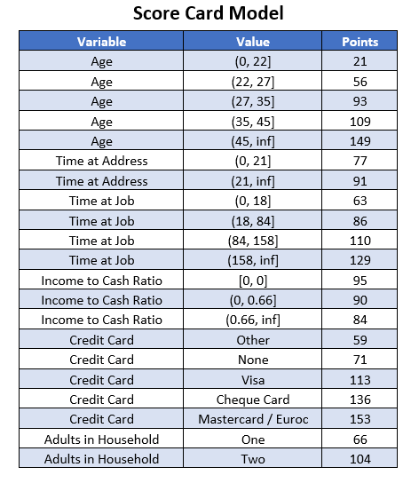

Figure

Figure 2: The score cutoff for granting a loan was chosen based on the scores on the test set. The test set was adjusted using the weights of each observation so that it would be more representative of the population of all loan applicants. The possible profit for every score cutoff from 400 – 600 was calculated and the optimum cutoff that maximized profit was found to be 519. Using this cutoff, the expected profit per customer is $833. The graph shows that as the cutoff score increases the profit increase up until a score of 519. After that point the cost of customers that default start to outweigh the revenue from customers that don’t default.

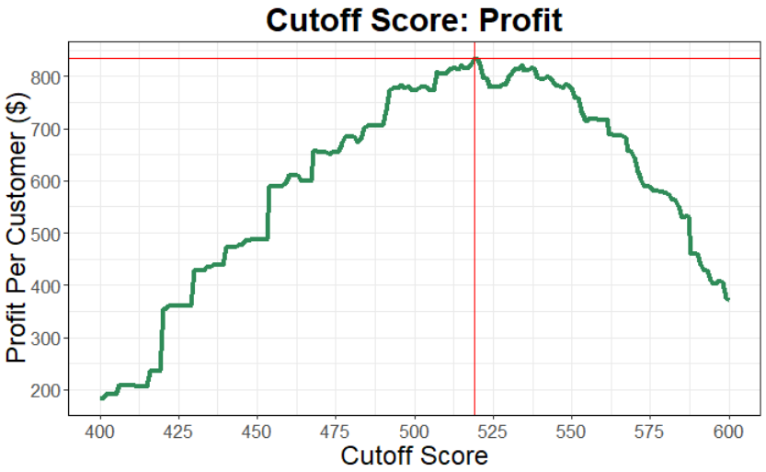

Figure

Figure 3: The cutoff score of >519 for granting credit is expected to result in an acceptance rate of ~75% and a default rate of 1.64% based on the adjusted test set. The plot shows that as the cutoff score decreases the acceptance % increases and the default % increases.

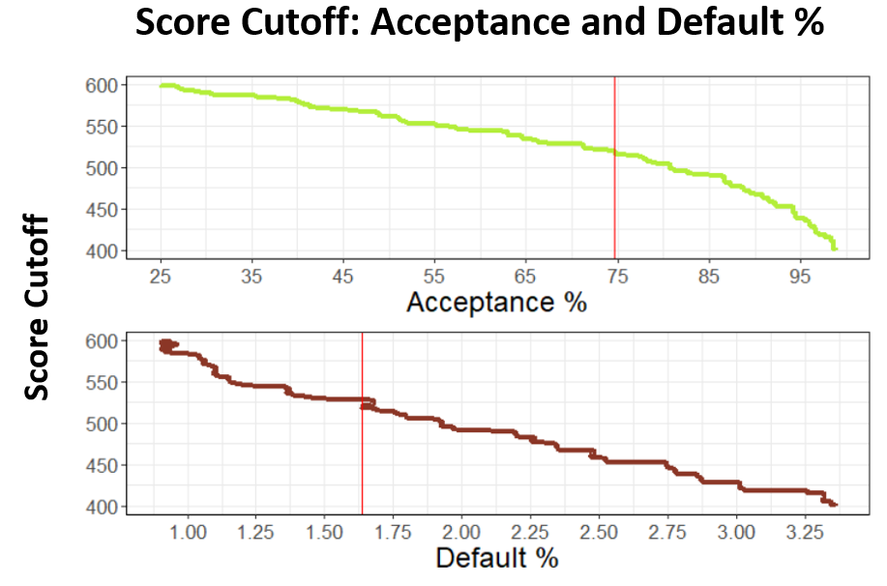

Figure

Figure 4: Scores for all samples were binned in intervals of 50. The predicted probability of default was averaged within each bin. The default rate was calculated by taking the number of people that defaulted within each bin divided by number of people in the bin. This shows that as the score increases the average predicted probability and the default rate decreases.

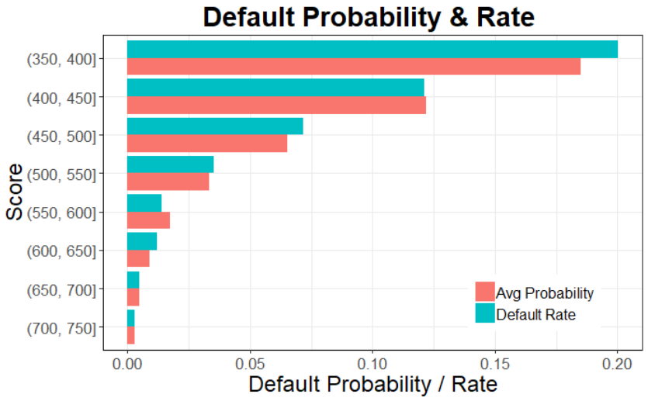

Figure

Figure 5: confusion matrix for the adjusted test set and using the cutoff score of > 519 for granting credit. The test set as adjusted using the weights of each observation to create a sample that is more representative of the population of credit applicants. Using the scorecard model and a cutoff of > 519 for predicting whether a customer would default is expected to have an accuracy of 76%

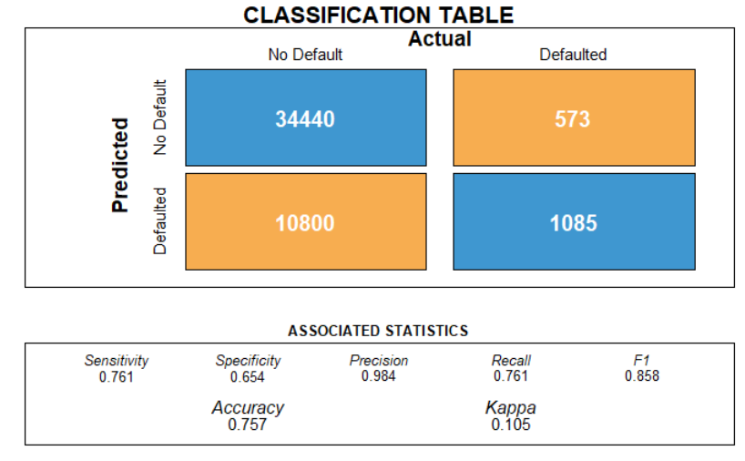

Figure